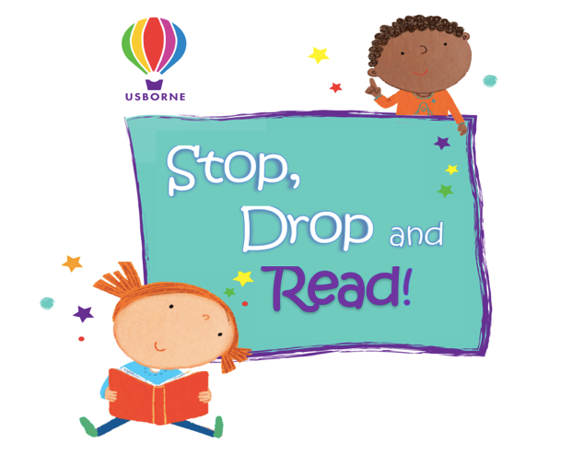
Reading Log
Vernon Primary School

Pupil name: …………………………………
Class: …………………….……………………
If you would like to receive a monthly email with new titles and special offers please add your email address:

……………………………………………..…………………………………………

Date | Minutes/  Pages/  books Read | Total | Adult signature
Monday 26 April

Tuesday 27 April

Wednesday 28 April

Thursday 29 April

Friday 30 April

Saturday 1 May

Sunday 2 May

Total Amount: …………………………………………………………………

Please return ALL sponsorship money & forms to Pip via email by Friday 7th May
you will be emailed an amount to spend on Usborne books!
Thank you for taking part in our Stop, Drop and Read.

Pip Langdon - Independent Usborne Organiser
Mobile: 07791 405247
Email: piplangdon_independentusborneorganiser@hotmail.com
Website: usborne.com/gb/organiser/piplangdon

