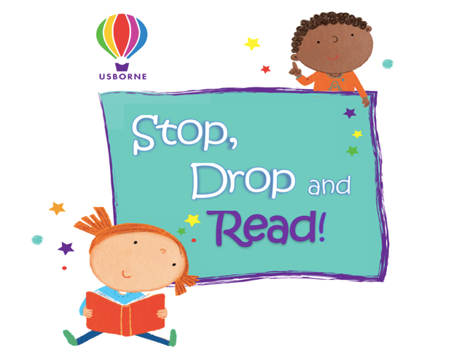
Sponsorship Form
Vernon Primary School

Pupil name: ………………………………………….

Class: …………………….…

Contact phone number. …………………………………………
(This is in case I need to contact you later regarding your choice of books. It will not be passed on to anyone else)

Name | Address and contact details | Sponsorship  (per min/page/book or total donation) | Amount collected | Total
Please continue on a separate sheet if necessary.

Total Amount: …………………………………………………………………

Please return ALL sponsorship money & forms to Pip via email by Friday 7th May
you will be emailed an amount to spend on Usborne books!
Thank you for taking part in our Stop, Drop and Read.

Pip Langdon - Independent Usborne Organiser
Mobile: 07791 405247
Email: piplangdon_independentusborneorganiser@hotmail.com
Website: usborne.com/gb/organiser/piplangdon

