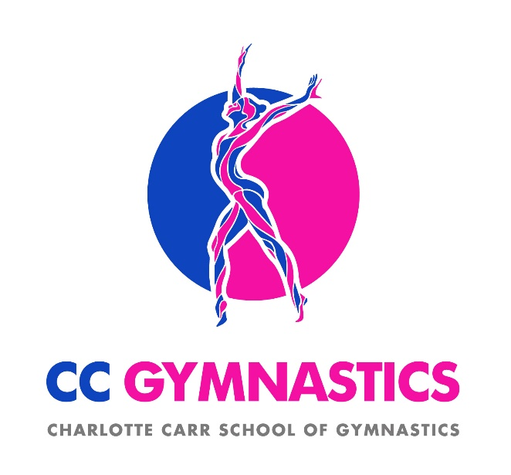
C.C. GYMNASTICS ltd
UNIT B, THIRD AVE., POYNTON IND. ESTATE. SK12 1YL
MOB. NO. 07399658303
Head Coach Charlotte Flanagan
Booking Form September 2021
Dear parents/guardian
Below are the dates and costings for our first term back term, Please make a note of the dates where there are no sessions. Some are half term dates and others are dates your school are using the hall.
Spaces must be paid for in advance for insurance purposes.
We hope your gymnasts enjoy your sessions!
 | Worth  Tues 3.30-4.30 | Vernon  Wed 8.15-8.45 | Lostock  Wed 3.15-4.15
FIRST SESSION | 7th Sept | 8th Sept | 8th Sept
LAST SESSION | 30th Nov | 1st Dec | 1st Dec
NO GYM | 26th Oct | 27th Oct | 27th Oct
SESSIONS | 12 | 12 | 12
COST | £54 | £39 | £54
PLEASE TICK CLASS
Please complete and EMAIL a photo/scan of this form to info@ccgym.co.uk
If you have any queries please do not hesitate to contact us through email or phone
-------------------------------------------------------------------------------------------
Childs Name_______________________________________________________
I have paid the full amount of £___________ by bank transfer
Contact Tel. No ...................................... E-MAIL ADDRESS.......................................
Signed_________________________________date_______________________

Terms and Conditions 2019 PLEASE READ
All lessons must be paid for in Advance
Pay by bank transfer:
Sort code 16-28-23 *Acc No - 10866720 *(Reference- child’s name)

Payments must be received by 06/09/21
Please complete and EMAIL a photo/scan of this form to info@ccgym.co.uk

A child’s place is booked and committed for the whole term, any cancellation during the term will receive no refund. Any information given to C C GYMNASTICS for example child's ability or medical details will be assumed to be true and accurate.
It is the parents/carers responsibility to notify us of any illness.
injuries or medical conditions likely to impede their safety or ability to participate.
Parents are requested not to use any form of picture
or video capture device whilst children are participating.
This is to protect privacy and comply with safeguarding/child protection regulations.
C C GYMNASTICS will not pass on any personal information we have to any third party.
Thank you,
C C GYMNASTICS, UNIT B, THIRD AVENUE, POYNTON IND. EST. SK12 1YL
EMAIL– info@ccgym.co.uk

